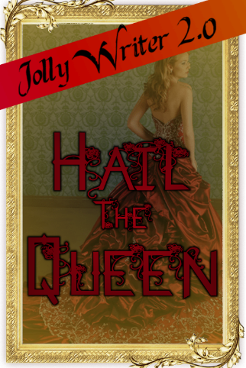
I had this thought when I was trying to type up some RoD last night... "Wouldn't someone have to take the throne of Duracia in modern times, after all the Haddocks [Hiccup, Uzuri, and their kids] step down?"

Wouldn't that be their kids?

yeah, but I wouldn't want each King/Queen to stay on the throne for CENTURIES!

they would step down at some point, become a member of the Duracian council or something, and pass the crown down to next in line in the royal family

So who is this queen?

and then each kid would have multiple kids, and eventually I feel like one member would decide to skip out on the responsibility and go back down to earth.

that member would not have joined the Dragon Riders, and so wouldn't have been made immortal/been gifted with a life of longevity from the Waterfall of Longevity in the Dragon Rider ritual thing I made up. So that member of the family would grow up to have completely normal HUMAN children.

I had an idea for a descendant of Hiccup and Uzuri [one of those COMEPLETELY HUMAN children on Earth] to be the only WORTHY member of the royal family, and so the next in line for the throne. Her name was to be Tessa Lee.

But then I read a story last name, a Harry Potter story, where Harry gets turned into a girl, almost completely permanently. The professors at Hogwarts decide to tell everyone Harry Potter left to be trained, and they had a new transfer coming in from New Zealand. This 'transfer' was really Harry in girl form, going by the name Rose Evans.

So a random thought crossed through my head, what if Harry was a descendant of the Royal Family of Duracia from his mother's side.

All descendants of Dragon Riders have dormant sorcery powers in them, royal family or not. So when the wizards of the Harry Potter world talk about Muggleborns, those muggleborns are really Dragon Rider descendants whose powers slightly activated. But because they aren't Dragon Riders, and didn't go through the ritual to be given or activate their powers, the only way they can channel that magic is through using wands, and maybe some wandless magic if they become accustomed enough.

So when a 'muggleborn' breeds with a wizard/witch, those half-bloods or really half-wizard/half-sorcerer or half-wizard/half-dormant dragon rider. That means they're EXTRA powerful

So if Harry Potter was not only a descendant of Dragon Riders, but also a descendant of the royal family, that would mean he's in line for the throne of Duracia. He could be the next King of Duracia, become a Dragon Rider, be a wizard AND an active sorcerer.

But then, something happens...

Draco Malfoy decides to pull a prank on Harry, only for him to use the wrong spell.

Harry Potter turns into a girl.

Harry has to go into 'hiding' as Rose Evans, the transfer from New Zealand.

Rose Evans: She's Professor McGonagall niece that decided to attend Hogwarts to be closer to her favorite aunt. She lost her bags on the trip over and had to travel to Muggle London to buy a whole new wardrobe. She's a powerful and talented half-witch that just so happened to be given Harry's classes in his absence.

At least, that's what everyone but a few close friends and the professors think.

The only ones that know aside from the professors and the Madam Pomphrey the nurse/medi-witch/healer/WHATEVER, are Hermione, Ron, Ginny, Neville, Seamus Finnegan, Dean Thomas, Lavender Brown, and Parvati Patil.

Not even Draco knows because he cast the wrong spell and doesn't know what spell it was that he really did cast.

The spell [i'm just gonna use the one from the story I read, since this idea is mainly an idea, not a future project] is Femini Mutatio, sometimes referred to as the 'Maiden's Blessing'. It was used back in old times to change male pureblood wizards into female pureblood wizards so that pureblood lines could continue 'untainted'. The spell becomes absolutely permanent once the boy-turned-girl loses her virginity, since the newly turned girl is automatically a virgin, whether she was a virgin or not when she used to be a boy. The only way for the spell to be countered is for the castor [in this case, Draco] to use the countercurse to turn the girl back into her former male self.

Thing is, Draco doesn't know Harry is a girl, and although Harry/Rose was automatically drawn to Draco [effect of the curse], she continues to become close to him and eventually date him, still as Rose, so the question would be, "Would she want to change back?"

Because it's such an old spell, there are barely any records of it, so it takes the professors and Madam Pomphrey months to even find references to the spell. When Severus Snape finally finds the cure, Rose and Draco are too far gone in their relationship. Too bad Rose had to ruin it a day before Christmas break by revealing to Draco the truth that's she's really Harry Potter turned into a girl, by Draco himself. Draco throws a fit, Rose leaves for Christmas Break with the Weasleys heartbroken, because Draco admitted that he loved her and would change his ways for her before she told him her secret, but she never got to tell him she loved him back.

While on break, Rose receives a letter from Draco [who's been mentally slapped upside the head by Snape for being an idiot/jerk/ass/git(if you want to be British)], but also gets a visit from one of the Royal Duracian Messenger birds...
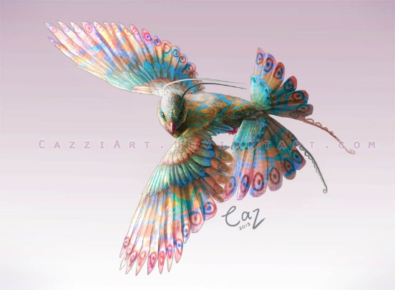

Through the messenger bird, Rose gets connected straight through to the Duracian Messenger room, a circular room that houses all the birds, along with the main bird in the middle [picture of bird below]. It's a large room that's very colorful because of all the birds in it. Messenger birds work as a link between the 'sender' and the 'receiver', like something between a phone and using video chat. The sender and receiver both look into the eyes of their respective birds [sender/main bird, receiver/messenger bird]. Their eyes glow the same blue as the main bird and their minds appear in a white void and they have their conversation, while their bodies that sitting/standing/lounging whether they originally settled before entering the void.
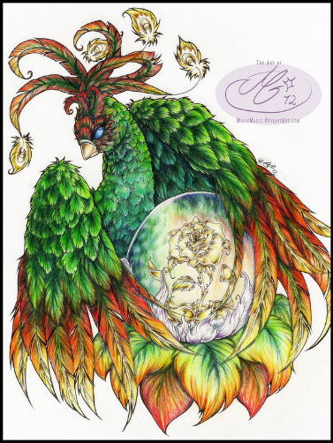

The 'sender', being Siofra, my character who is immortal just like Dragon Riders, tells Rose [at first surprised because she should have been a boy named Harry, only to face-palm because she remembers this change in a prophecy dream she recently had] that she is next in line for the Duracian throne, being the only worthy royal descendant that hasn't refused yet. Siofra also defuses any and all pressure by saying Royal Family members are always Dragon Riders, and so immortal, so they can easily wait for generations for the next in line if need be. But not wanting to give up the chance or trouble her apparent relatives/ancestors, Rose accepts the throne.

now where did i leave off...

Siofra tells Rose that in a few months time, she must visit the Great Earth House to be picked up, giving her the coordinates. The 'Great Earth House' idea is something I made up while in my history class.

let me explain that before continuing.

Have to go now, but here's a diagram of sorts of the Great Earth House I was talking about. Read the thing I typed while I'm on the road.

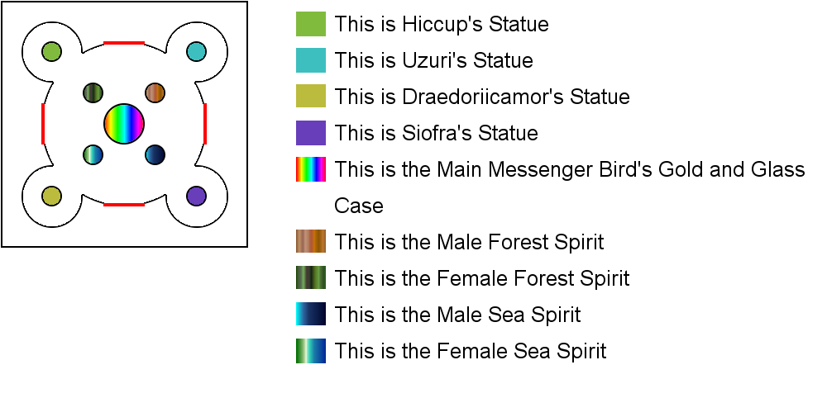
This is like the floor plan for the Great Earth House. This GEH is a real thing in the future for RoD. The box around the little picture is just there to frame the floor plan

the Great Earth House is like Duracia's equivalent of a church, basically. But instead of worshipping their gods or something, it works more like a phone booth.

It has another one of the large Main Messenger Birds on a stand in the middle of the structure, surrounding by a gold and glass cage/case. By using the bird, you can get a connection to Duracia.

The circles are just where the statues are. The little extra circles surrounding four outer statues are like little open-plan rooms. One statue would be of Hiccup, the First True King of Duracia, and Toothless would be behind him, so there's something on both sides. The second statue is of Uzuri, the First True Queen of Duracia, and her dragon whose name i forgot but have it typed down somewhere...The third is of Draedoriicamor, the Ancient One, and also the Dragon elder. The fourth is of Siofra, the Royal Meetorai [which is something like a prophet/psychic, and also a word I made up...]

wait, no, it's Meetorae, 'e', not 'i'

The four others statues are of the Male/Female Forest/Sea Spirits who are like the Ambassadors of the forest and large lake on Duracia. the sea spirits are Laquis {male} and Adamaris/Sedna {female}[not sure which to use yet]. the forest spirits are Akamu {male} and Damia {female}.
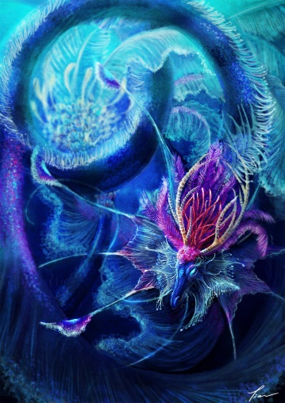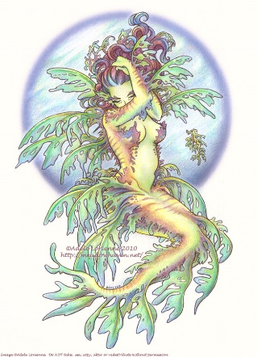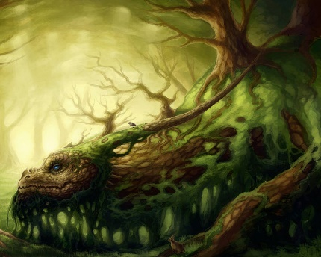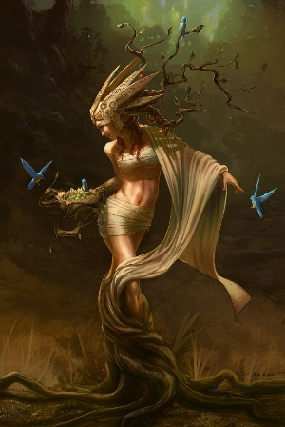

So the Great Earth House is basically a church inspired phone booth.

The red lines are the exits, just to be clear.

And what happens to rose? :x

And Draco? :x

Yeah, now that the GEH is explained, i need to get back to that...

Ok. So by the 21st century, there are GEHs like everywhere because Duracians have taken to living on Earth to live in more urban cities since although the island of Duracia has taken it upon itself to expand for its growing population, the Duracians have stuck to living naturally, either still in the old-fashioned village, underwater, or in the forest. Unless you live in the castle with the Dragon Riders and the Royal Family.

BACK TO...THING: So Rose is given coordinates to the closest GEH to Hogwarts [if you get sent to bed, you can always read this tomorrow. i'm probably gonna go to bed around 11]. So she goes back to Hogwarts after the break [i know i'm 19, but i'm 10 years old inside], and [because in the letter, Draco apologizes to her, saying how although she used to be Harry Potter, he did truly fall in love with her, and if she'll have him back, he'll be waiting] and practically jumps into Draco's arms.

DRACO IS NOW A SWEETHEART WITH SOME jerky TENDENCIES!

Severus Snape gives Rose the news that he couldn't find a cure, at least not one he could preform. She accepts the news in stride. She might've wanted to change back into Harry before, but now she has Draco, her life has become easier and a little normal since no one sees her as The-Boy-Who-Lived, and she's made more friends throughout the experience.

What of Draco did he accept her?

Did he accept rosa as she is and love her?

"because in the letter, Draco apologizes to her, saying how although she used to be Harry Potter, he did truly fall in love with her, and if she'll have him back, he'll be waiting"

Yeah but you also said he has jerk tendencies :x

he realized that maybe he only pushed Harry away because of how they met.

and yeah he has jerk tendencies. he can't be Draco without being a jerk to some people sometimes

even if it's only an insult here or there

So anyway, Ron was like Harry's first friend, so when Harry met Draco he was kinda snotty, a little brat. Then when they get off the train and arrive at Hogwarts, he goes and insults Ron right in Harry's face and holds out a hand in friend. Harry sees a potential 'Dudley' in Draco, then, and refuses to take his hand.

So that happened in first year, and they became rivals in the years to follow. So when they basically get reintroduced with Harry as Rose Evans, it was like a new start

Did he ever wonder what happened to Harry?

And how did they explain it?

I mean he was the caster after all
Draco got to know Harry through Rose, and Harry got to know Draco AS Rose. But they're not gay/homosexual, so Harry now being a girl means they can be together. Now that she's a girl, she's all of a sudden interested in guys, the same way she was interested in girls as Harry.

Dumbledore told the whole of the school that Harry had left to be trained to be prepared to fight Voldemort, but really Harry became Rose Evans, the transfer student

So Draco thinks Harry is off training, and Rose is a potential temporary girlfriend, since she's pretty, even though she's a Gryffindor. But then he truly falls in love with her.

At the end of their sixth year, Rose gets a visit from the messenger bird again and knows she has to go to the GEH. The GEH is kind of secret, and only Duracians can find it. So even if someone who is not Duracian or of Duracian blood knows the coordinates, the magic around the GEH would stray them away, making it so they never find it. So Rose BRINGS along the gang [Draco, Hermione, Ron, Neville, Ginny, Seamus, Dean, Lavender, Parvati, and now Luna Lovegood] so they can wish her farewell

with her hair being more of the color of the girl in green, and with Harry's signature emerald green eyes

when Harry turned into a girl, he got his mother's, Lily Potter nee Evans, looks. so that means he kept his green eyes, but his black hair turned into a nice rich Auburn color [a mix of these girls but with green eyes]

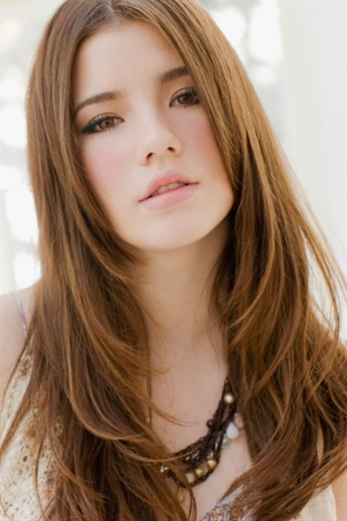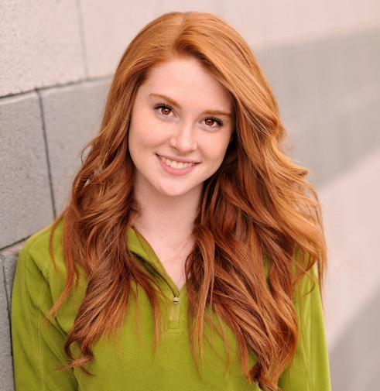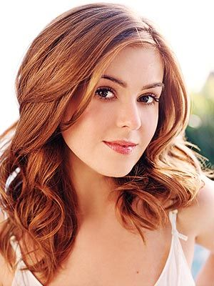

Your Result
Fun-Loving
The guy that suits you the most knows how to have fun. He loves trying new things and exciting adventures. He definitely lives life to it's fullest. He is understanding, funny, and sweet. He completely gets you, and you love that. He can always find time for you.

Shit. Jamie is the one.

So we both like the same kind of guy...this is why Freddie has to be a closet-Jamie. He has to act all cool and collected for his Slytherin counterparts, but he's sweet, funny, and understanding in private and only with those he lets close

So anyway, Rose goes to the GEH with the gang, an airship is waiting for her, and she says her goodbyes [hugs all around with a kiss for Draco] {airship below} and heads off to her future kingdom.

okay,, basically anything that has to do with Duracia, is truly a idea i have for RoD, so take it in now.

For the whole of the summer, Rose is trained to become a true Dragon Rider, going through the DR trials, making a sacrifice to the Flames of Honor, and getting her sorcerer powers and becomes immortal [sorry, took a second to take my pills. birth control to lessen pain and blood flow for periods, iron pill because all of my heavy period bleeding has made me anemic, and another i have to go get for vitamin D] plus she now has a dragon counterpart. let me get a picture...

so that summer goes by in like a month or two [normal] for the wizards on Earth, but training feels like it took years for Rose [since potential Dragon Riders go somewhere special to train away from civilians where time is slower] so when she returns to her friends, she's leaner, has packed some toned muscle, is agile like nothing else, and can pack a punch [like punch through a steel door kind of punch]. she's got a complete hold on her music and is more powerful than ever before. She's becoming a warrior, like her ancestor before her, Uzuri of Rome, First True Queen of Duracia.

while she was on Duracia, Draedorii recognized the foreign soul in her [since Harry Potter is apparently a Horcrux, meaning he has a part of Voldemort's soul in him, keeping Voldemort alive] so they go through a ritual to remove the foreign soul from her own soul, destroy the soul after finding out whose it is, and now she isn't a Horcrux and doesn't have to die like Harry did in the book/movie.

So she spends the rest of the year until May [since that's when the Battle of Hogwarts starts and Voldemort is destroyed on May 2] hunting down the other Horcruxes with Hermione, Ron, and Draco, and running away from not only the Ministry of Magic but also Death Eaters. They get away everytime because of Hermione's quick acting and Rose's powers [GO GIRLS GO!]. Dobby doesn't die because Rose uses her powers, they save Luna and Mr. Olivander [or however you spell his name] {picture below}

