The Girls of Duracia, friends of Rose. Left to Right: Eilir-a butterfly fairy, Elwyn-an elf, Lyris-a Lagua, Kyden- a half elf/quarter human/quarter Elemental, and Rose-a human witch. And a human Lyris

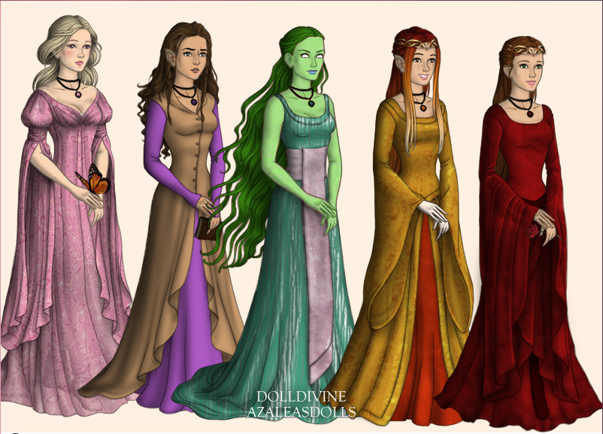
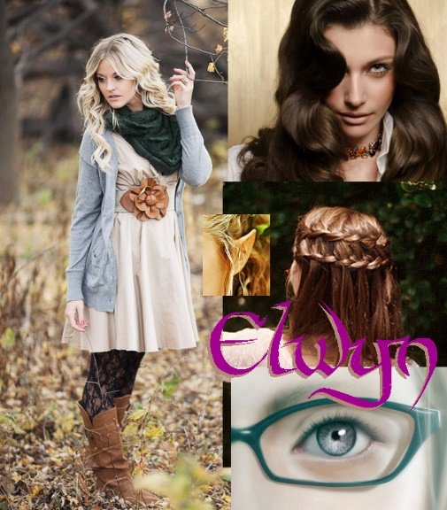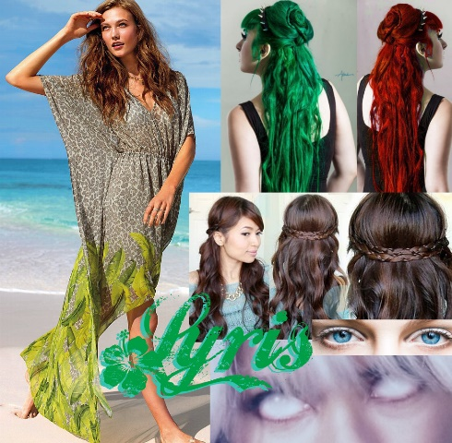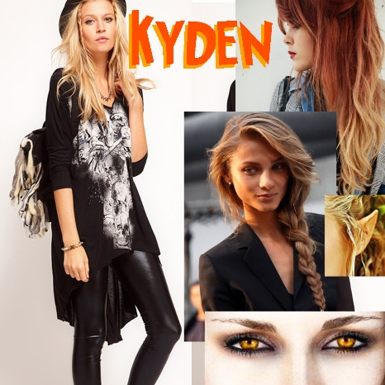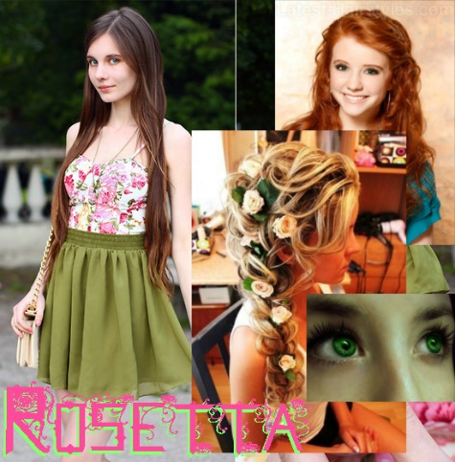
The Boys of Duracia, friends of Rose and her girls. Left to right: Kraygin-a human, Alvar-an elf and Elwyn's brother, Kayode-an Animaebi/Elemental descendant, and Voshell-half human half night fairy.

