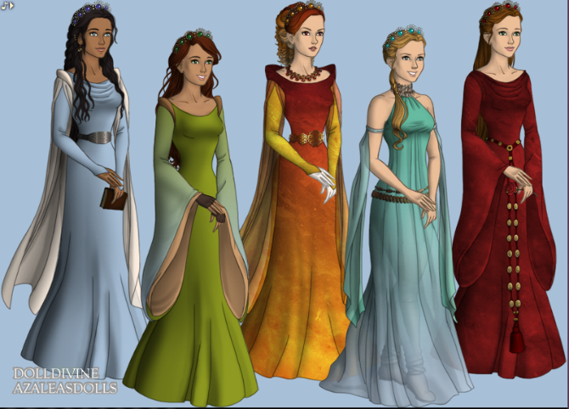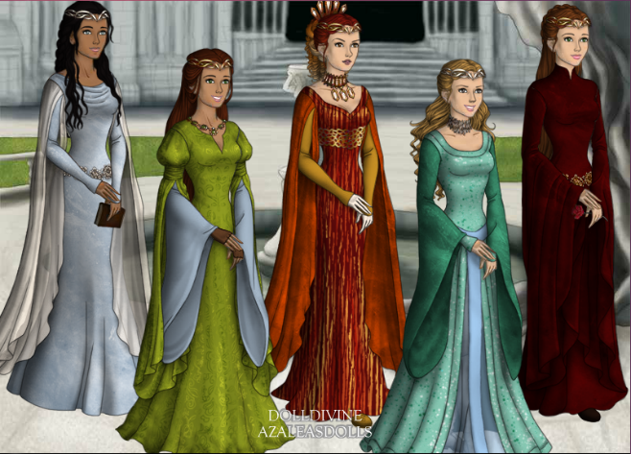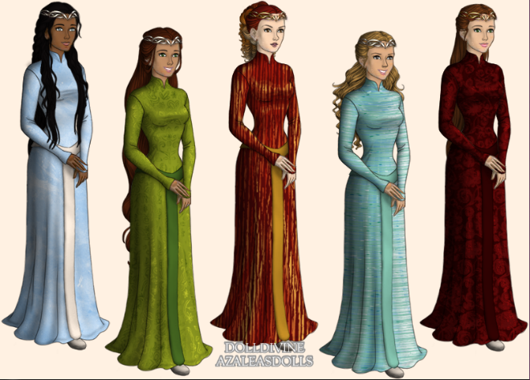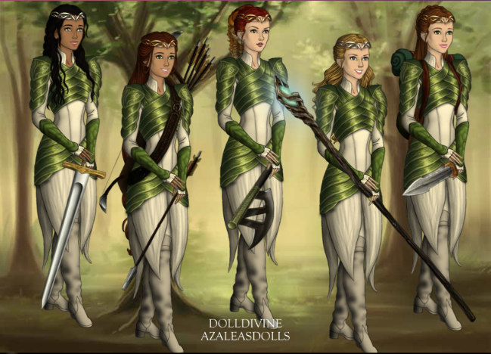

Queen Uzuri of Rome, the First True Queen of Duracia [Queen during second half of RoD and all of RoD's sequel, "Battle of Duracia"]

Queen-to-be Princess Ayanna, the Pure Royal Queen of Duracia, daughter of King Hikke and Queen Uzuri, the Dragon Rider Prodigy[Young princess towards end of RoD, and the teen princess and young Dragon Rider in RoD's sequel, BoD, crowned as queen at end of BoD]

Queen Ignacia of Spain, the Half-Elemental Queen of Duracia, Royal Blood Descendant of King Hikke and Queen Uzuri through her mother, Queen Pyralis, her father a Dragon Rider recruit from Spain [Queen for most of the third story in my Duracia Fanfic Trilogy, "Descendant of Duracia" and the queen who hands down the crown to Tessa Lee, or Rose in my Harry Potter spin off]

Queen Tessa Lee of America, the Earth-Raised Queen of Duracia, the long lost Queen of Royal Blood, descendant of King Hikke and Queen Uzuri through THEIR son, Prince Donar of the triplets, Princes Delling, Donar, and Dyre [the girl who is the subject of the third story, "Descendant of Duracia", a college student who believes that she's just a normal girl, aside from all her strange accidents (her dormant Dragon Rider magic shining through), who is hunted down by followers of Devin Blake, a Dark Wizard who takes after Marietta since she switched to the Pure side, leaving the Dark side without a leader, Tessa Lee is contacted by Siofra to come to Duracia, while also sending Dragon Riders to protect her, she later becomes the Queen of Duracia towards the end of DoD, after fighting as an inexperienced Dragon Rider in the battle against Devin Blake and his dark creatures]

Queen Rosetta of England, the Half-Witch Queen of Duracia, the long lost Queen of Royal Blood, descendant of King Hikke and Queen Uzuri through THEIR son, Prince Dyre of the triplets, Princes Delling, Donar, and Dyre, her mother is the Duracian Descendant while her father is a pureblood wizard [I believe you know the story for this, all you need to know is that Queen Ignacia is the Queen who hands down the throne and crown to her]

