they've been torturing her her whole life. having Mel there, as her subconscious, will actually help her remember all those experiences, in vivid detail, and it'll be like she's reliving them all over again. plus I feel that leaving her in the cellar like they couldn't give a damn is the worst torture they could do to her after all of what they've already done.plus i'm gonna make it so Mel also helps her remember some things from when she was too young to remember without Mel's help. because of that, she learns that Richard Bennett is her biological father who had been having an affair behind Astoria's back, and then brought baby Marietta to the Bennett Manor, where Astoria finds out about the affair and refuses to let Mari live under her roof as any more than a servant. as she grew up, Marietta starts to look more and more like the mother that died giving birth to her. and so Richard, being the disgusting bastard that he is, starts to feel lust towards his own daughter and rapes her. so although she goes crazy and kills Richard and Astoria, Marietta's possibly saved James and Emily from the fate of getting molested by their own father

so James and Emily are Marietta's half-siblings, and she'll have gone so crazy by the time she learns of Richard's little secret, that that'd never come to mind to her, and so she leaves her siblings behind after killing their parents

i'm starting to realize how very messed up I am

xD you're not!

You're far more straight than I am!

i'm making Marietta's life hell

I love the way you develop your characters

And how each has a story behind them and the plot too

I hope my imagination comes up with a VERY spectacular happy ending for Marietta in the sequel

It's okay many people have lives like that

I've already planned how Uzuri is going to die

It's just that mari didn't have anyone to tell her it was okay like most do.

D; NO!

Uzu can't die D;

...yes...

she's not gonna die RIGHT AWAY!

WHY?! D;

because she's awesome and will sacrifice herself for the good of the world despite Hiccup's attempts at saving her

I... I wanted her to be the grate grate grate grand queen of duricia when we came back as Hogwarts students ;-;

What about hiccup?

see this?
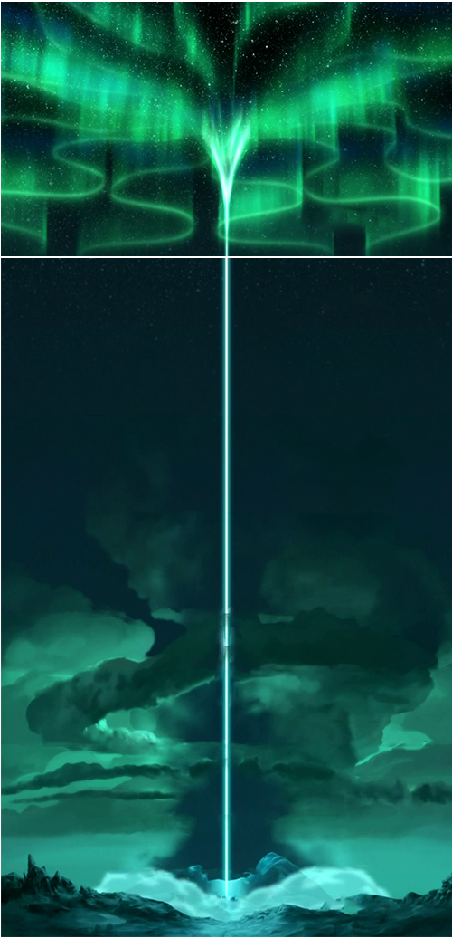
ok, now picture Uzuri at the bottom of that beam of light

picture her all avatar like, eyes and mouth and everything glowing

something from the dark depths of the world, a.k.a. Marietta's former home by that time, has lost all control and has turned to pure chaos

a darkness is threatening to consume the world and everyone on/in it

and it's all coming from that point in the dark world, like some dark cloud that kills everything it comes in contact with

ok, let me explain real quick

in Riders of Duracia, later in the story, Marietta uses the dark magic that she's gained to make a dark world, where only dark creatures reside, within the depths of the earth
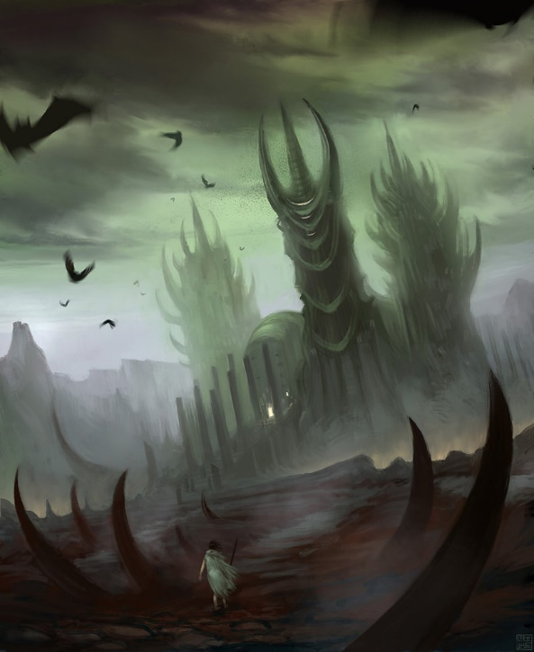

it's located somewhere in Antarctica, but no one can find it, because like Duracia, it has a magical shield around it that makes it invisible to the naked eye and makes all wanderers turn back before that can reach it

if you manage to make it past the shield, that picture above is what you see

but what Marietta didn't know is that the dark magic she used wasn't in her complete control, meaning it was building up over time

after Marietta finds peace after the sequel, Battle of Duracia, in a one-shot, i'm gonna write about how that dark magic had finally broken Marietta's control, becoming a cloud of dark, fire, and ice that threatens to consume the world

the Dragon Riders on Duracia work hard to fight the darkness, calling back in action, the by then retired from royal duty, Hiccup and Uzuri to help find a way to fight it. Draedoriicamor, the ancient dragon, knows that this darkness is too powerful to combat. if more ancient dragons like him still existed, they could possibly have fought the darkness, or at least weakened it greatly. by then all but the Haddocks (Hiccup, Uzuri, Queen Ayanna, and the triplets, any others I think of throwing in there) have lost hope in saving the world

Uzuri finds a way of using her Dragon Rider sorcery to fight back against the darkness, but at a cost of her own life, indefinitely. Hiccup refuses to let her go along with it

promising to never go along with her plan, Uzuri secretly spends months building up her own power within her, making peace with those that mean so much with her.

after years and years of the DR fighting back to at least keep the darkness at bay, Uzuri has had enough and decides to take her plan into action. she consults with the island, Duracia, in hopes that it would support her and help her do what she has to to save everyone. so after spending a last passionate night with Hiccup, she gets him to visit the heart of Duracia, the Flames of Honor within the cave-like Waterfall of longevity, tells him she loves him and that she hopes he'll forgive her, before leaving him inside, Duracia helping to keep him locked inside with its magic long enough for her to reach the highest point of Duracia

she performs a ritual before chanting, her body slowly glowing, her hair turning white, her eyes and mouth glowing bright. as her chants come to an end, that beam of light erupts from her, sending that Aurora borealis, or whatever, all across the sky, eventually pushing the darkness back into its place back in Antarctica, hopefully forever.

after the darkness has been conquered, Hiccup is finally released and when he goes to where Uzuri had performed the spell, he finds her lying down on charred ground , her body surprisingly in perfect condition. but her hair and eyes have lost their color, her skin is ice cold, and her heart has stopped beating. Hiccup screams to the heavens in devastation. he has lost the love of his life, and he's never getting her back

they perform the usual funeral ritual, dressing her in an elegant white gown, wrapping her in sky blue silk, laying her on a floating bed of roses, that they let float out to the middle of the usual funeral lake, which is surrounded by golden lilies. they sing the funeral song all together in honor of their First True Queen and their savior, and as her body reaches the middle of the lake, a beam of sunlight opens up the clouds and shines down on her, just like with all other funerals, and her body glows so bright, one cannot see her body, until the light dies, and all that is left is a floating golden lily in the middle of the lake. Hiccup uses his powers to help the lily float to shore, picks up the flower, and, like he's done so many times before, plants the flower along side the others in the grounds that surround the lake. once the lily is planted, all the lilies start to glow together and Uzuri's flower shoots up a beam of light that creates a rainbow in the sky, and everyone knows uzuri is watching over them from a better place. Hiccup sheds a tear, and he also smiles, knowing that she still loves him, just as he will always love her

the end

