does this sound interesting?

Hm?

Heirs to The Throne of Adäɭaɛya:

Iɭsamer Gängiʈi'me̞r, The Banished: First Born to the King and Queen of Adäɭaɛya. Older to her sister, and second born, by 15 years. Conspired against the throne when doubt in her capabilities as a leader was ruining her chances at becoming queen. Suspicions about her behavior forced her parents to banish her from Adäɭaɛya, their own daughter. Hiring assassins, and striking a deal with the enemy, Iɭsamer succeeded in killing her parents, the so-called ‘Stronghold of the Sea’, and leading Saxon men to battle the Adäɭaɛyan forces and hide any trace of her presence. Her actions were in vain for her father’s second in command, a Lord of a southern village of Adäɭaɛya, had taken the throne as Regent until one of her young siblings could rule. With them sent out into hiding for their safety until adulthood, Iɭsamer takes this time to plot to steal the throne from the chosen heir, even if they are of her own blood. It would not be the first time.

Eʙeri'ɭynn Gängiʈi'me̞r, The Great: Second Born to the King and Queen of Adäɭaɛya. Younger to Iɭsamer by 15 years, older to Daegän by 3 years. Conceived when the King and Queen questioned the leadership of their First daughter, born mere days before her sister is banished. Eʙeri'ɭynn was said to be the Awaited One, the heir that Adäɭaɛya needed, especially as conflict against magic to the west was coming upon them. Many had faith that she was the champion of the All Mother, others of western heritage believe her to be the prophesied Emrys. In hopes of raising her differently, the King and Queen decide to provide her company in the form of a younger sibling. Shortly after Daegän is born, Iɭsamer strikes and both young royals are sent into hiding. Daegän is sent North and his caretakers change his name to Dorian to avoid discovery. Eʙeri'ɭynn is sent to the Southeast and has her named changed to Merɭynn. She grows under the care of a noble couple as if she were their very own daughter until the Lord passes, just five years of his Lady, leaving her in the care of her dreadful step-mother. That is, until she runs away at 15 years of age, spending a year traveling along the western lands of Adäɭaɛya until she comes to a man willing to take her across the sea to the lands of Albion. Another year is spent with a woman by the name of Hunith in the little village of Ealdor in western Escetir. Under the woman’s advice, Merɭynn travels to Camelot and her journey to fulfill her destiny begins.

Daegän Gängiʈi'me̞r, The Pure: Third Born to the King and Queen of Adäɭaɛya. Younger to Iɭsamer by 18 years, younger to Merɭynn by 3 years. Born mere weeks before her parents’ demise, Daegän grows up the son of a Lord and Lady in the North, only ever going by the name of Dorian. Raised by the Lord and Lady into adolescence, Daegän knows no other life, though is taught the ways of the court and told of his bloodline and the truth behind his living with the couple he has seen as his parents his whole life. Expecting his older sister, Eʙeri'ɭynn, to be undergoing the same lessons and training, he is shocked to learn that she had gone missing when knights of Adäɭaɛya sent to retrieve her from her safe haven on the eve of her 18th birthday. She had been missing for almost three years, with no knowledge of her lineage due to her caretakers (and the only ones in the know of her royalty) having passed in her childhood, and with no leads as to where she could be. Though never knowing his sister, Daegän vows to find her himself and, at 15 years of age, takes his own squad of Adäɭaɛyan knights on the search for his sister. With only a description and a botched up alias (as her step-mother and sisters couldn’t bother to remember hers, only knowing her by a name meaning ‘From the Smoke’), the returned Prince of Adäɭaɛya adventures across many kingdom in hopes of finding the Light of Adäɭaɛya, his older sister. That’s if his oldest sister doesn’t find her first.

thoughts?

It sounds interesting o.o
But you may want to rephrase The beginning

how so?

I dont know I had to read it twice... But youre using too many words to describe it

ok, thanks
I tend to do that to try and sound all 'superior', hoping to make it sound legit, but always end up just completely explaining everything in the end

Yeah xD a bit much this time

SKIPPED PERSONAL CONVERSATION…

Do you even know how hard it is to find pictures of princes and guys with dragons on google images?
Very hard

-caugh- daneries -cough-

You mean Daenerys? Because there's plenty of her. I'm looking for MALE dragon riders. Very hard to find, especially with close ups of the guy

When it comes to fantasy art, girls reign

that movie called eragon

Amateur fan art. I've looked
They they have really good art, just screenshots and posters from the movie

:0

They have good fan art for the dragons, but not much for the riders
and to make my search even harder, the prince/dragon rider needs to have blonde hair. preferably white blonde hair
SKIPPED PERSONAL CONVERSATION….

i'm having a bit of a crush on one of my own characters...

WHO IS IT...

Merlyn's little brother...

i wanna ask who finds her first....
but at the same time i dont wanna ask o.o
and gimme dibs on his personality C:

it looks something like this

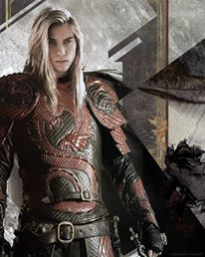

and his inner spirit animal is a seahorse

hm

you can read up if you want http://www.whats-your-sign.com/symbolic-meaning-of-the-seahorse.html

https://scontent-lga3-1.xx.fbcdn.net/hphotos-xfa1/v/t1.0-9/376418_218586628263701_1095770068_n.jpg?oh=2bc41b36ba70e6244dc4dc17b525d488&oe=569743AA
i had to.
i wanna go to an aquarium now...

he's a patient, friendly, and generous person who isn't in a hurry to change himself for anyone. this makes him a bit stubborn but in an endearing way: he will not back down from a challenge and will not give up just because things got tough. he is very understanding and looks at all perspectives of a situation before making a decision; this also makes him understanding of women and their role in the human species, seeing them as more than just breeders, but mothers, daughters, lovers, warriors, queens. which makes him completely accepting of his older sister's chance of being heir instead of him, as he understands she is just as capable as him and is older than him. he loves with all his heart and is a bit carefree, but also protective of those he cares for. he is also aware of nature and its importance, and also cares to take in the full picture, never overlooking one detail for another. this makes him perceptive

I have a better seahorse, one befitting a DragonLord with a seahorse spirit

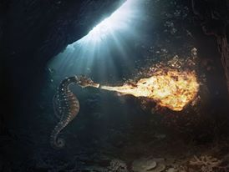

XD

FIREBREATHING SEAHORSE
when I was looking for dramatic seahorse pictures for an edit, I couldn't help but keep this one

xD
and he sounds wonderful

do you know of any white haired male characters? i'm stuck with just Daenerys' two older brothers, Legolas from Lord of the Rings, and Jack Frost from Rise of the Guardians. I've gotten most of my picks from Daenerys' older brother Rhaegar, but they're too obviously from Game of Thrones

hm o.o
https://www.google.com/search?q=white+haired+young+man&biw=1221&bih=602&source=lnms&tbm=isch&sa=X&ved=0CAYQ_AUoAWoVChMIwJ_gy6ivyAIViD8-Ch3g3QGf

i'm gonna guess you don't know any?

nope o.o

girls are so much easier. this is Merlyn and her older sister Ilsamer. Merlyn is the one with black hair

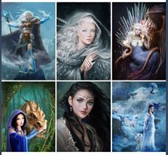

:O

yeah, Ilsamer is based off a mix of evil Elsa from Frozen and Daenerys Targaryen
Merlyn's just...Merlyn with inspiration from almost all Disney princesses

x3

grown up Ilsamer and Daegan(Merlyn's little brother)!

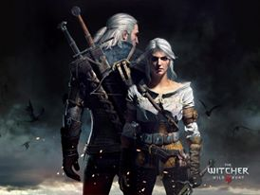

if that male character (Geralt) didn't look so old, he'd be the perfect source for Daegan's look

why does a thirty something look younger than
oh

Ilsamer also has powerful magic and so can either make herself stay young, or her magic makes her immortal. that could be a reason for why the little brother looks older

but...
then...
how is merlyn and danny going to um...
you know..

no I don't. don't hesitant to ask questions. they help me develop my story/characters

i mean how are they going to defeat her?

Merlyn has powerful magic too, she's just not as murderous as Ilsamer. Daegan is trained in combat, unlike Merlyn who only knows how to hunt, and has a little magic of his own. not as powerful as his sisters', but enough to let his combat skills take care of the rest. that with the fact they're all dragonlords and so can call on dragons, and Merlyn has the force of Camelot's men through Arthur, and Daegan has the force of Adalaeya's men

Merlyn's magic is also more powerful than Ilsamer's but Ilsamer is more trained in it and more experienced with it

hm... so eternal emprisonment?
gah... this conversation is on hold D:

SKIP…

almost done, thinking of changing out one or two of the pictures

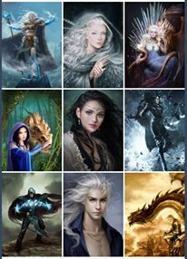

i am done!!

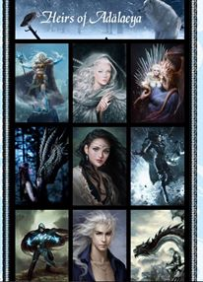

and as you can see, i purposely left Daegan with powers that look weak compared to his sisters' powers

:0 i see

